|  |
| --- |
| PS2Win |
| Weekly Report |
| Keep Your Time |

|  |
| --- |
| Filipe Brandão  21-04-2013 |

**Team Members:**

Carla Machado

David João

Filipe Brandão

João Girão

João Martins

Mário Oliveira

Rui Ganhoto

**Week 9**, 15th of April to 22th of April

Content

1. Week Activities 1

1.1. Work Executed 1

1.2. Work Analyses 1

1.3. Achievements 1

2. Impediments 1

3. Plans For Next Week 2

4. Progress 2

4.1. Earned value and/or Gantt Image 2

4.2. Effort by task 3

4.3. Individual effort 3

5. Individual log 4

**Images**

Figure 1: Earned Value 2

Figure 2: Week effort by task type 3

Figure 3: Week effort by team member 3

**Tables**

Table 1: List of Contributors ii

Table 2: Version history ii

Table 3: Log of individual effort 4

|  |  |  |  |
| --- | --- | --- | --- |
| **Authors and Contributors** | | | |
| **Date** | **Name** | **Contacts** | **Contribution** |
| 21-04-2013 | Filipe Brandão | a21180276@alunos.isec.pt | Author |
| 22-04-2013 | Mário Oliveira | a21170292@alunos.isec.pt | Contributor |
|  |  |  |  |
|  |  |  |  |
|  |  |  |  |

Table 1: List of Contributors

|  |  |  |  |  |  |
| --- | --- | --- | --- | --- | --- |
| **Revision History** | | | | | |
| **Date** | **Description** | **Author** | **Version** | **Approvers** | **State** |
| 21-04-2013 | Creation of first draft | Filipe Brandão | 0.1 |  | Draft |
| 21-04-2013 | Ready for Revision | Filipe Brandão | 0.1 |  | Ready for Revision |
| 22-04-2013 | Forgot to add milestones dates correction to Work Executed. Updated EV | Filipe Brandão | 0.2 |  | Ready for Revision |
| 22-04-2013 | Document reviewed | Mário Oliveira | 0.2 |  | Ready for Revision |
| 22-04-2013 | Changing State | Filipe Brandão | 0.2 |  | Ready for Approval |
|  |  |  |  |  |  |
|  |  |  |  |  |  |
|  |  |  |  |  |  |
|  |  |  |  |  |  |
|  |  |  |  |  |  |
|  |  |  |  |  |  |
|  |  |  |  |  |  |
|  |  |  |  |  |  |
|  |  |  |  |  |  |

Table 2: Version history

# Week Activities

# Work Executed

* Client Interview
* Use Cases and Mockups updated
* Continuation of Requirements Definition
* Continuation of Test Plan
* Baselined Project Assessment and Control Process
* Reviewed Verification & Validation Process
* Risk Meeting
* Baselined Coding Standards
* Process Map
* Milestones dates corrected

# Work Analyses

Interview with the client wasn’t initially expected but turned to be very useful in order to provide a better understanding of the client needs. Requirements, Use Cases and Mockups required some updates to fit the results of the interview. Knowing the interview results, the Technical Manager promptly identified the need to change the UI Framework to be used.

Members allocated to Requirements Definition tasks reported that their work for this week went normally.

Tests Plan definition is strangely taking a lot of effort (double of the Requirements Definition effort) causing it to be overbudget and there is still work to do. Members allocated to this tasks are not comfortable with the continuous changing of the requirements.

A team member felt a little frustration because there were no tasks allocated to him during this week. To occupy his free time, he autonomously decided to start developing UI test concepts (using a new UI Framework) revealing true engagement with the project.

# Achievements

* Client interview
* Baselined Project Assessment and Control Process
* Baselined Coding Standards
* Process map

# Impediments

* Verification & Validation Process was not baselined due to some kind of misunderstanding leading to the author thinking that there were no defects pointed during the review. Also, two different authors requested two different team members to approve the document revealing some communication issues between team members.
* There was plenty disagreement during the Risk Meeting. The concepts of risk/problem were not clear for the team.

# Plans For Next Week

* Finish the remaining Process
* Get SRS ready for Inspection
* Prepare for the SRS Inspection

# Progress

# Earned value and/or Gantt Image

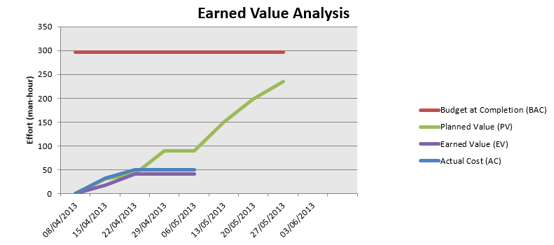

Figure 1: Earned Value

Planned Value = 41,3h

Earned Value = 41,3h

Actual Cost = 50h

# Effort by task

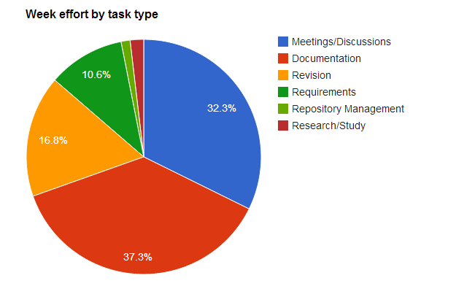

Figure 2: Week effort by task type

# Individual effort

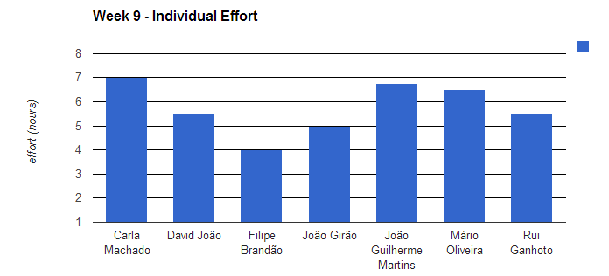

Figure 3: Week effort by team member

|  |  |
| --- | --- |
| **Name** | **Effort(hours)** |
| Carla Machado | 7 |
| David João | 5.5 |
| Filipe Brandão | 4 |
| João Girão | 5 |
| João Guilherme Martins | 6.75 |
| Mário Oliveira | 6.5 |
| Rui Ganhoto | 5.5 |

Table 3: Log of individual effort

# Individual log

**Carla Machado - Tasks done:**

* Revision of Project Assessment and Control Project – 1h
* Writing meeting minute - 0.5h
* Approving Verification and Validation - 1h
* Process Map - 1h
* Risk meeting - 0.75h
* Update use cases - 0.75h
* Second Revision of Project Assessment and Control Project - 0.5h
* Discussion of the results of the interview with the client - 0.5h
* Review of the agenda for the next meeting and Approval of SDP and coding standards -1h

**David João - Tasks done:**

* Discussions -0.5h
* Review Process Map - 0.25h
* Risk Meeting - 0.75h
* Continue writing acceptance tests - 3.5h

**Filipe Brandão - Tasks done:**

* Approved meeting minute - 0.25
* Fixing earned value - 0.25
* Updating dashboard - 0.25
* Risk Meeting - 0.75
* Updated mockups - 0.5
* Discussion of the results of the interview with the client - 0.5
* Approved V&V Process - 0.25
* Updated SDP (Milestones) - 0.25
* Approved Coding Standards - 0.25
* Weekly Report - 0.75h

**João Girão - Tasks done:**

* Prepare Interview (prepare mockups, study uses case and prepare questions) - 0.5h
* Interview with the client - 1.25h
* compile information of the interview - 0.25h
* Discussion of the results of the interview with the client - 0.5h
* Process map discussion - 0.25h
* Requirements Definitions - 1.5h
* Risk meeting - 0.75h

**João Martins – Tasks done:**

* Interview with the Client - 1.25h
* Changes in Verification & Validation Process - 0.75h
* Remaking and continuing Test plan - 4.5h
* Approval Assessment and control process - 0.25h

**Mário Oliveira - Tasks done:**

* Revision weekly report - Week 7 - 0.25h
* Revision Verification & Validation Process - 0.5h
* Revision Coding standards document - 0.5h
* Prepare Interview (study uses case and prepare questions) - 0.5h
* Interview with the client - 1.25h
* Revision software development plan document - 0.25h
* Requirements Definitions - 1.5h
* Risk meeting - 0.75h
* Process map discussion - 0.25h
* Discussion of the results of the interview with the client - 0.5h
* Update repository - 0.25h

**Rui Ganhoto - Tasks done:**

* Project Plan Approval - 0.25h
* Meeting Minutes Approval - 0.25h
* Risk Plan Meeting - 0.75h
* Meeting Summary Review - 0.25h
* Changes on Project Assessment and Control Process - 1.5h
* Discussion of Client Meeting Results - 0.5h
* Technology concept proof using WPF and VS2012 - 0.75h
* Project Assessment and Control Process Ready for Approval - 0.25h
* Coding Standards Changes - 0.75h
* Software Development Plan Approval - 0.25h